BSL-2 Laboratory
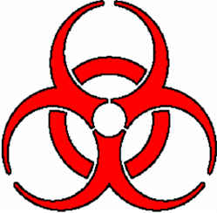
BIOHAZARD
All Personal Protective Equipment shall be removed prior to leaving this work area. Eating, drinking, smoking applying
cosmetics or lip balm and handling contacts lenses area prohibited in this work area.

Name of infectious agent(s):

________________________________________________________________________________________________________________________

________________________________________________________________________________________________________________________

Transmission route(s):

_______________________________________________________________________________________________________________________

Special requirements for entering this area:

________________________________________________________________________________________________________________________

Emergency contacts
P.I. Name: Office: _______________ Home: _______________ Cell: _______________

EH&S office (M-F 8-4:30) 438-8325 (after hours) 911.
__________________________________________________________________________________
*Biosafety Level 2 is similar to BSL-1 and is suitable for work involving agents of moderate potential
hazard to personnel and the environment. It differs from BSL-1 in that
1.Lab personnel have specific training in handling pathogenic agents and directed to competent scientist;
2. Access to the lab is limited when work is being conducted:
3. Extreme precautions are taken with contaminated sharp items and
4. Certain procedures in which infectious aerosols or splashes may be created are conducted in biological
safety cabinets or other physical containment equipment hazard to personnel and the environment.
Illinois State University
Environmental Health & Safety
Date _______

