BSL-1 Laboratory
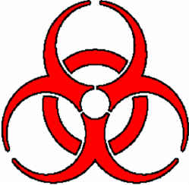
BIOHAZARD
All Personal Protective Equipment shall be removed prior to leaving this work area. Eating, drinking, smoking applying
cosmetics or lip balm and handling contacts lenses area prohibited in this work area.
Name of infectious agent(s):

________________________________________________________________________________________________________________________

________________________________________________________________________________________________________________________
Transmission route(s):

________________________________________________________________________________________________________________________
Special requirements for entering this area:

________________________________________________________________________________________________________________________

Emergency contact
P.I. Name: Office: _______________ Home: _______________ Cell: _______________

EH&S office (M-F 8-4:30) 438-8325 (after hours) 911.
__________________________________________________________________________________
*Biosafety Level 1 is suitable for work involving agents that are not associated with potential
hazard to personnel and the environment.
Illinois State University
Environmental Health & Safety
Date _______

